Please e-mail me with any questions or bug reports: John Serences, serences@jhu.edu
Last updated, July 2nd, 2003

System Requirements:
1) DX 7.0 or better
2) windows 2000, win XP, seems to work on Win 9X computers with adequate video cards.
3) The program will attempt to set your monitor to 1024x768 or 800x600 with 32bit color depth. In either case, the 32 bit color depth is needed for the colors to come out properly. Make sure your monitor supports on of these display modes.

How it works:
Enter subject name, number, run number. This has to form a unique combination or you will be prompted to enter new info.

After the program is running, you can exit by pressing the escape key.

Click the ADVANCED button to modify parameters.
SEE BOTTOM OF DOCUMENT FOR SAMPLE SETTINGS

1) Checkerboard Attributes.
a) Degrees per slice: Degrees in a single slice of the radial flashing checkerboard.
b) Angle of smallest Circle: visual angle of the smallest visible portion of the central checkerboard. Usually set this to non-zero so that the checkerboard does not go all the way into fixation.
c) Radius of fixation point: In pixels.
d) mm of Cortex per Patch: Parameter for cortical magnification of the checkerboard stimulus relating to the estimate amount of cortex stimulated at each eccentricity, see (Horton and Hoyt, 199?, Slotnick et al, 1999)
e) E2: parameter for cortical magnification, see above refs.
f) A: see above refs.
g) This is the visual angle from the center of your display to the edge of your display, entered in degrees: the more accurately you calculate this number, the more accurate the cortical magnification equation will be.

4) Wedge rotation: either clockwise or counterclockwise.

5) 'Display mode', if exclusive, then the display looks much better (no tearing), but this may not work on some machines. Try it out.

6) Mapping technique
a) Normal polar mapping with a single rotating wedge.
b) Slotnick style bi-field mapping (Slotnick and Yantis, Human Brain Mapping, 2003). When using this technique, the 'Seconds per Rotation field' is the time it takes for both fields to be completely stimulated. This value should be set to incorporate two extra 'wedge thicknesses'. i.e., the wedges disappear into the vertical meridian with each cycle, so you need to account for this. We typically use a value of 84 seconds (this means it takes 84 seconds
from the start of stimulation till both wedges have disappeared into the vertical meridian completely and each field has been stimulated twice). Also, the 'Number of Cycles' field refers to number of complete 360 degree sweeps of one of the radial stimuli, thus if you set this number to 4, then each field will be stimulated 8 times.
c) Meridian Mapping: Alternately stimulates the vertical and horizontal meridian for ‘Seconds per Rotation’ duration.
d) Wedge mapping: Mapping of some arbitrary number of wedges of the visual field. E.g. you could use it for mapping the four quadrants. You can enter the number of desired wedges into the text box. If you want the wedges to be randomly presented (without replacement) on each cycle, then check the Random button.

7) Detection task. If enabled, then a flash of the chosen 'target color' will appear in the stimulus wedge every 'Targ Sep' +- (.5* Targ-Sep). Just to keep people interested and awake. Jens Schwarzbach originally thought of this. This feature only works when doing Polar or Slotnick mapping.

8) Colors, you can customize the colors of the checkerboard, etc. These only come out as expected if 32 bit color depth.

9) Wedge Attributes: Wedge thickness in degrees of polar angle.

10) Start Position of Wedge: where the wedge starts, usually 90 degrees.
For meridian and wedge mapping, this number corresponds to the middle of the wedge.

11) Timing Attributes:
a) Reversals per second: Number of checkerboard reversals per second.
b) Seconds in a Rotation: For polar mapping, how long it takes the wedge to go all the way around. For Slotnick mapping, how long it takes for both fields to be completely stimulated twice. For meridian, the amount of time spent on each meridian. For wedge mapping, the amount of time spent in each location.
c) Number of Cycles: for polar, number of rotations of single wedge.
for Sotnick, number of time that each field is stimulated twice (if set to four, then each field stimulated 8 times). For meridian, number of times vertical and horizontal stimulated.
d) Duration of initial fixation: Time from the start of the scan (first synch pulse) to the start of the visual stimulation.
e) Duration of ending fixation: Time from end of visual stimulation to end of scan.

12) Scan Info
a) number of start TRs to discard: if you are not using dummy scans at beginning of run, then you can set this value to wait for a specified number of TRs before the program starts. Then, these first few TRs of data can be used for functional->anatomical co-registration (due to anatomical like qualities) and discarded from the actual analysis (Brain Voyager has a nice way of doing this).If this last sentence did not make sense, then leave this value set to 0.
b) TR duration: enter the duration of you TR so that the automatic calculation of 'Number of TR's in a run' will be accurate.
c) Num TRs: See comment above: given an accurate TR, then it will display the number of TRs in the run, including fixations, discard TRs, etc.

Synching with the scanner:
To change the method of synching with the scanner, you should press the ‘Synch Pulse’ button on the lower left of the ‘Advance Dialog’. This will give you three basic options.
- Serial Port: You can enter the decimal value of the synch pulse as received on COM1. You can also change the Baud Rate of the connection.
- Parallel Port: Set the decimal value of the synch pulse, as well the register that the synch pulse is being sent on. If you don’t know what this means, check out http://www.doc.ic.ac.uk/~ih/doc/par/doc/regpins.html which is a cool page diagramming the structure of the PP. In order for the PP read routines to work, you must install DLPortIO, which is included in the zip file. This is a dll written by a third party that allows easier access to the PP under windows XP and 2000/NT.
- Keyboard: if you select this option, the program will start whenever any key is pressed after the fixation point comes up.

Subject Data Output:
1) First, do not move or delete or rename the 'Subject Data' folder. The program looks for this folder as a place to dump the behavioral data.
2) A data file is created for each subject, including all of the parameter info that you used, and timing info for when the wedge completed each rotation.
3) When doing wedge mapping, the wedges are numbered in a counterclockwise pattern, starting with 0 being the upper-most wedge in the upper left quadrant. The program will mark the location of the wedge next to the time in the data file.

Known Bugs: 11.18.02
- Slotnick mapping only works counter clockwise.

Sample Settings:
For Normal Polar Mapping

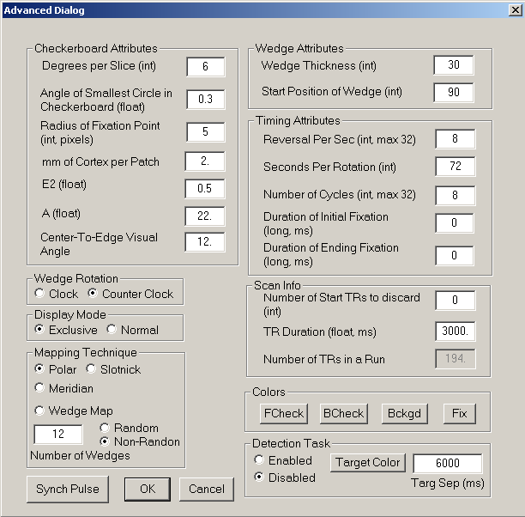

For Slotnick Mapping:

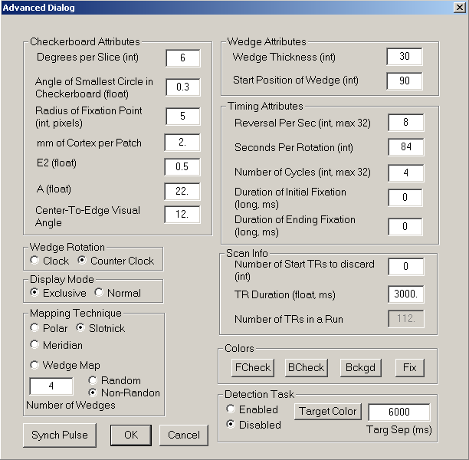

For Meridian Mapping:

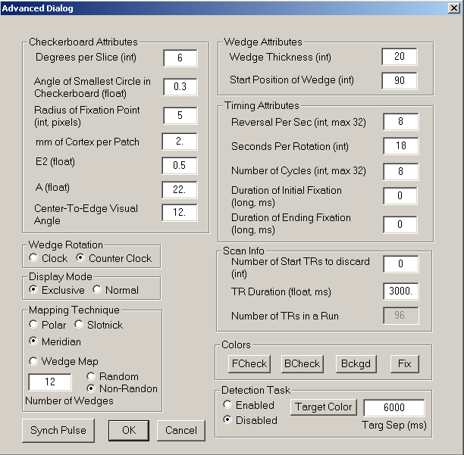

For Wedge Mapping (the four quadrants):

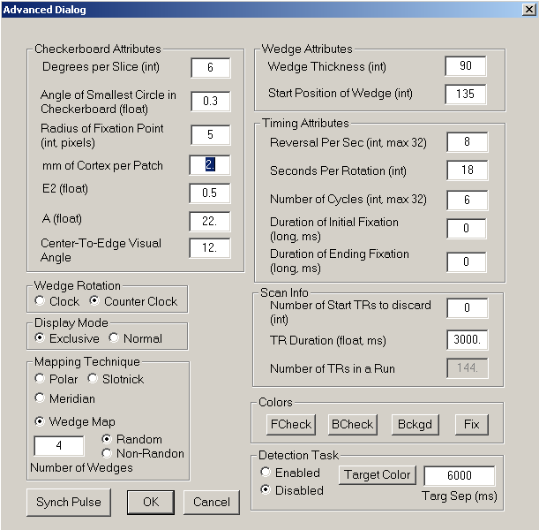

For wedge Mapping (8 Locations):

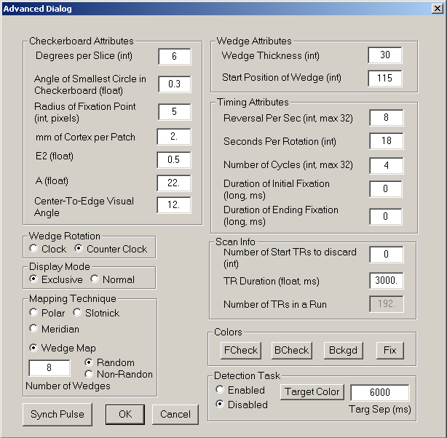
For wedge Mapping (12 locations):

